The Gospel of God

What About Israel?
Romans 9:1-14

The Prophecy

The Gospel of God
The Letter of Romans

The Gospel of God
What About Israel?
Romans 9-13/Genesis 21:12/Genesis 18:10, 14/Genesis 25:23/Malachi 1:2-3

- Paul's Unceasing Sorrow
Romans 9:1-5

- Has God's Word Failed?
Romans 9:6-14/Deuteronomy 30:6/Genesis 18:10, 14, 21:12, 25:23/Malachi 1:1-5

A person is not a Jew who is one only outwardly, nor is circumcision merely outward and physical. No, a person is a Jew who is one inwardly; and circumcision is circumcision of the heart, by the Spirit, not by the written code. (Romans 2:28-29)

And he is then also the father of the circumcised who not only are circumcised but who also follow in the footsteps of the faith that our father Abraham had before he was circumcised. (Romans 4:12)

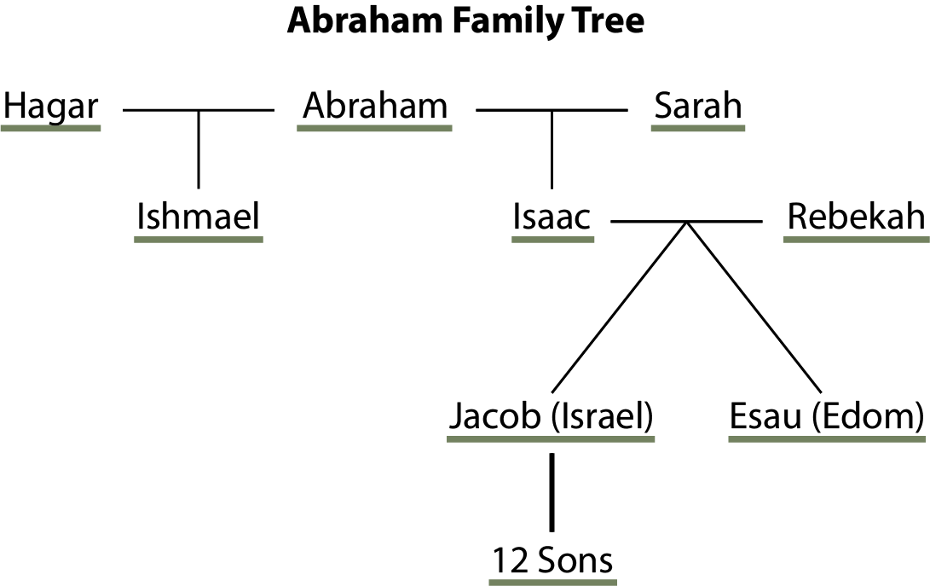
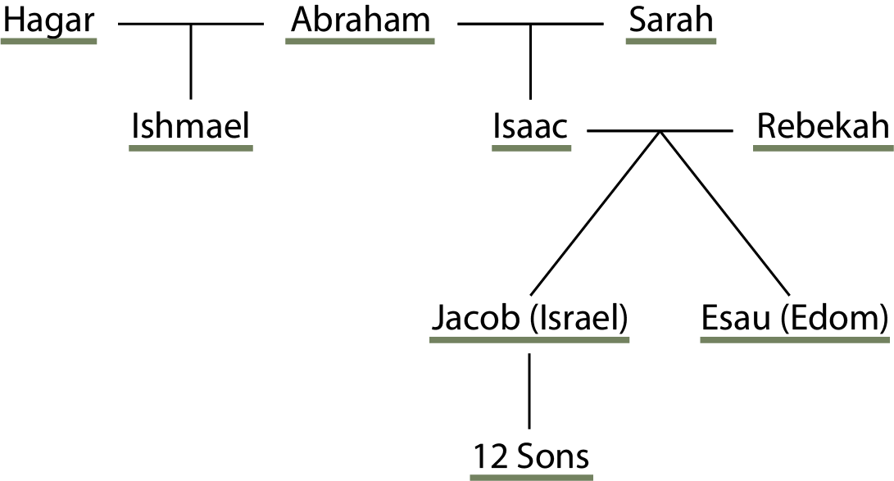

The Gospel of God
One Key Question

- _______ _________ . . . _____ You _________ ___________ The _________?

I speak the truth in Christ–I am not lying, my conscience confirms it through the Holy Spirit–I have great sorrow and unceasing anguish in my heart. For I could wish that I myself were cursed and cut off from Christ for the sake of my people, those of my own race, the people of Israel. (Romans 9:1-4)

For the Son of Man came to seek and to save the lost. (Luke 19:10)

